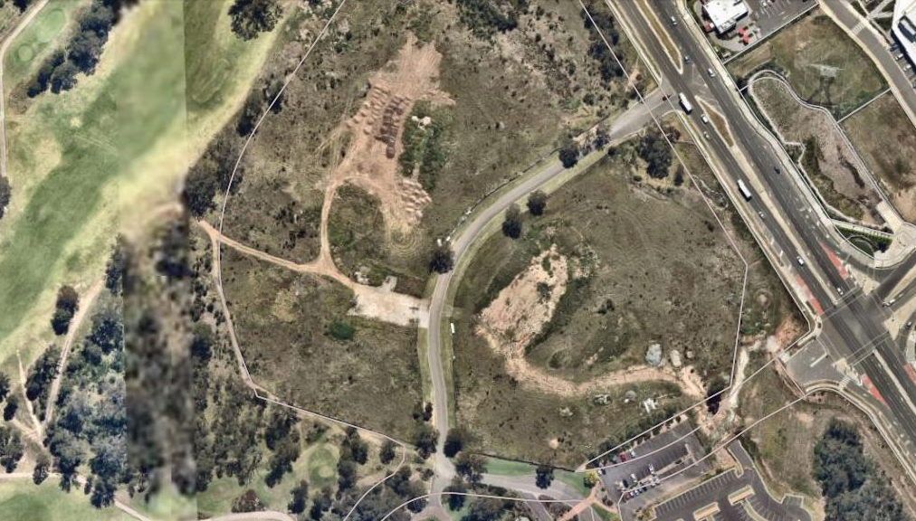
Image 1 – Aerial photo of site. Note the cleared pathway at the property boundary separating the development site (900 Camden Valley Way from the adjoining Golf Course Land (50 Raby Road).
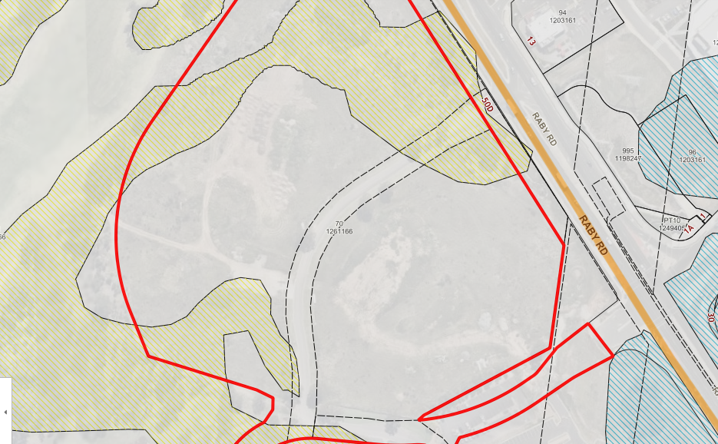
Image 2 – Environmental Sensitive Land mapping. Surrounding vegetation is mapped as Shale Plains Woodlands.
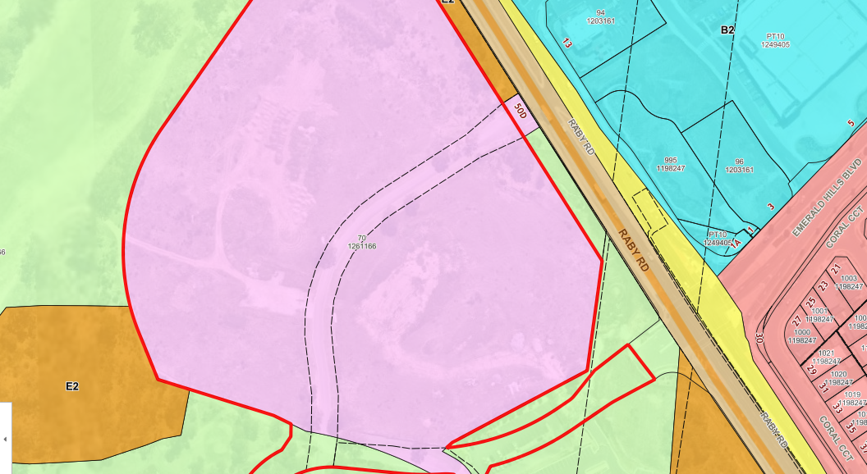
Image 3 – Land use zone overlay against aerial site image. Note disparity between land mapped as E2 – Environmental Conservation and vegetation mapping.

